SCHOOL OF COMPUTER SCIENCE AND ARTIFICIAL INTELLIGENCE |  |  |  |  | DEPARTMENT OF COMPUTER SCIENCE ENGINEERING
Program Name: B. Tech |  |  |  | Assignment Type: Lab |  |  | Academic Year:2025-2026
Course Coordinator Name |  |  |  | Venkataramana Veeramsetty
Instructor(s) Name
  Dr. V. Venkataramana (Co-ordinator)
  Dr. T. Sampath Kumar
  Dr. Pramoda Patro
  Dr. Brij Kishor Tiwari
  Dr.J.Ravichander
  Dr. Mohammand Ali Shaik
  Dr. Anirodh Kumar
  Mr. S.Naresh Kumar
  Dr. RAJESH VELPULA
  Mr. Kundhan Kumar
  Ms. Ch.Rajitha
  Mr. M Prakash
  Mr. B.Raju
  Intern 1 (Dharma teja)
  Intern 2 (Sai Prasad)
  Intern 3 (Sowmya)
  NS_2 ( Mounika)
Course Code |  |  | 24CS002PC215 | Course Title |  | AI Assisted Coding
Year/Sem |  |  | II/I | Regulation |  | R24
Date and Day  of Assignment |  |  | Week11 - Tuesday | Time(s)
Duration |  |  | 2 Hours | Applicable to  Batches
AssignmentNumber:22.1(Present assignment number)/24(Total number of assignments)
 | Q.No. | Question |  |  |  |  |  | Expected Time  to complete
 | 1 | Lab 22 – Advanced Ethical Considerations: Addressing Complex Scenarios and Limitations  Lab Objectives:  - Understand ethical concerns in AI-assisted coding.  - Explore complex real-world scenarios where AI decisions have consequences.  - Learn to identify limitations and biases in AI-generated solutions.  - Encourage critical thinking and human responsibility in AI collaboration.  Task 1 – AI and Inclusivity  • Ask AI to generate a chatbot for customer support.  • Test if it handles multiple languages or accessibility features (e.g., screen readers).  • Discuss:  How lack of inclusivity creates digital inequality.  Ethical ways to ensure accessibility in AI-generated systems  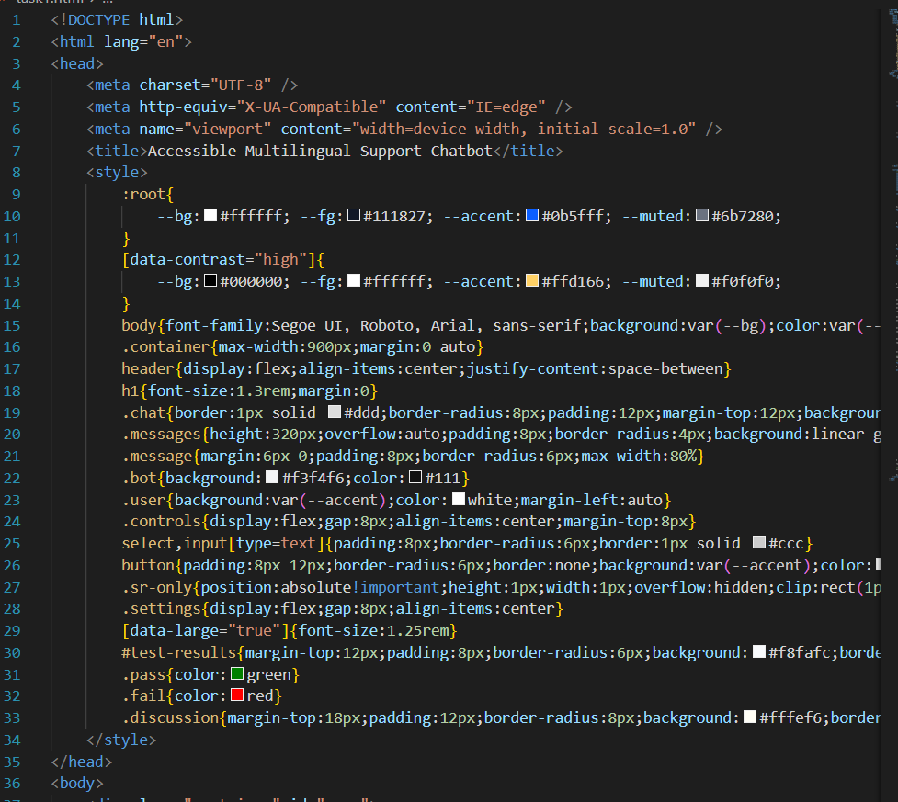  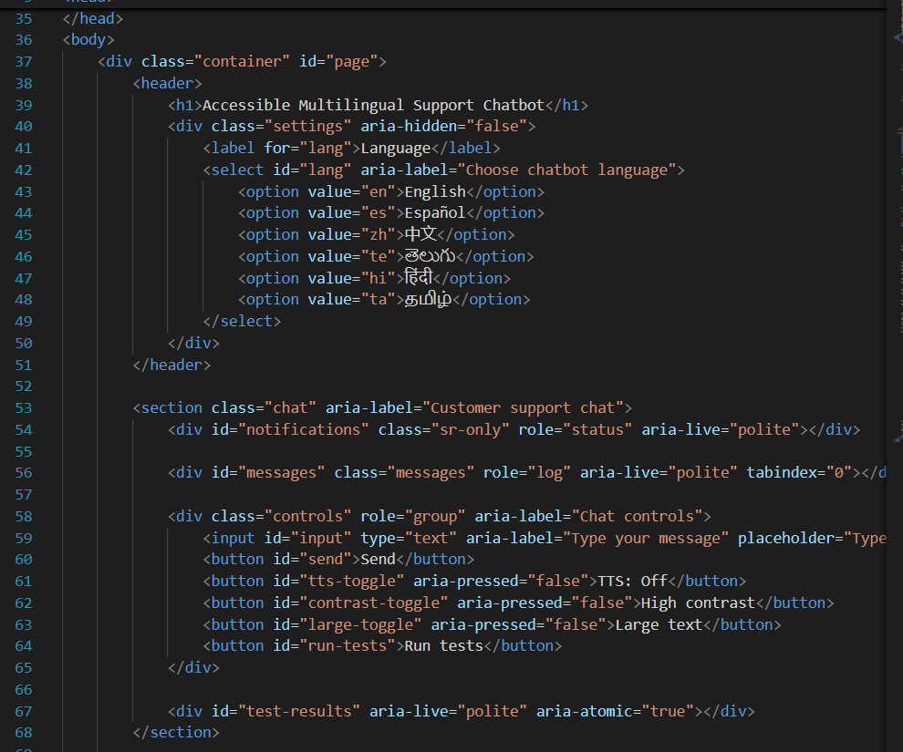  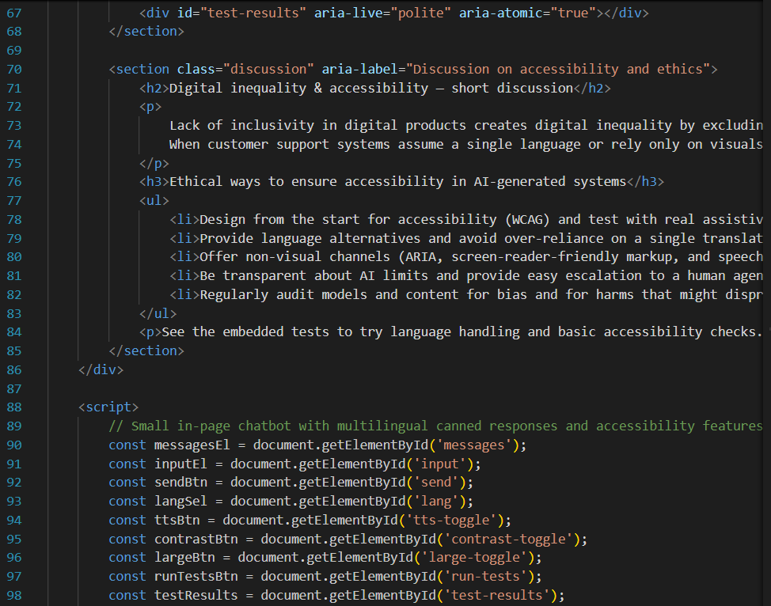  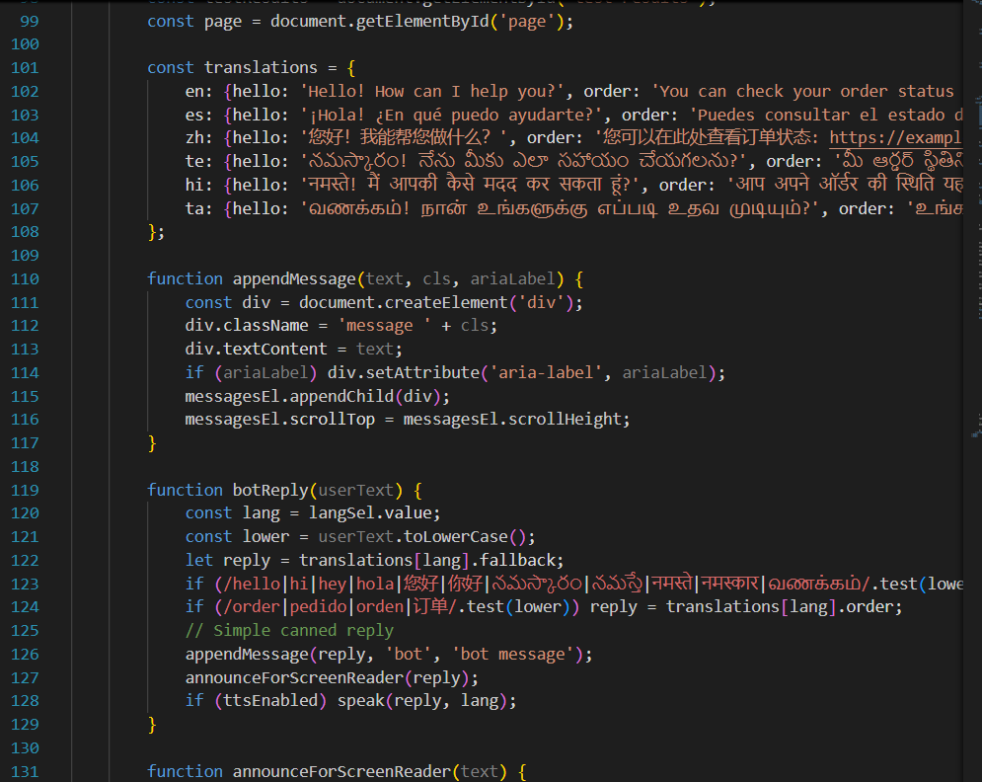  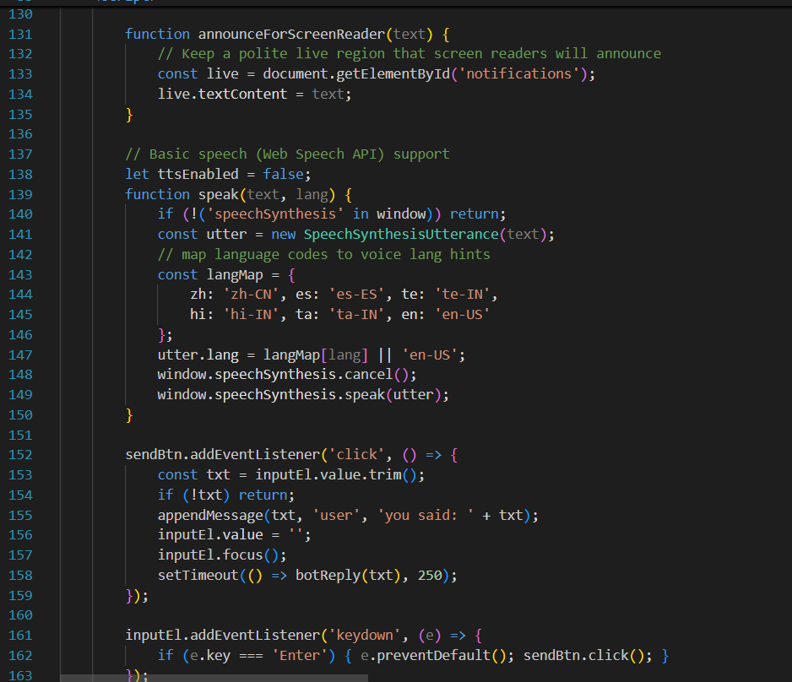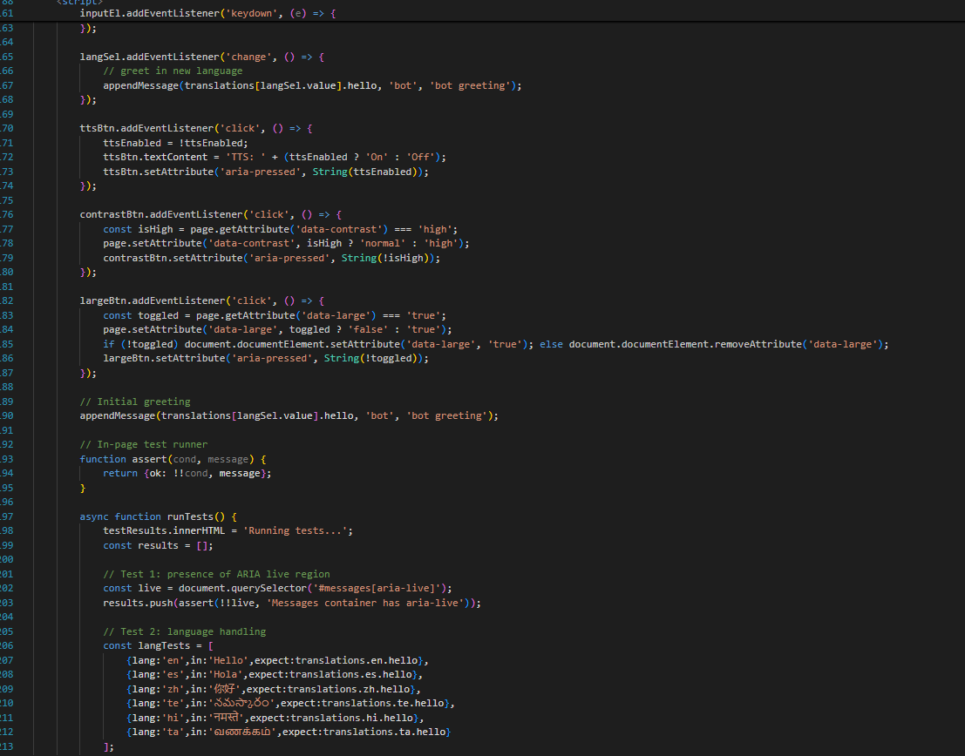  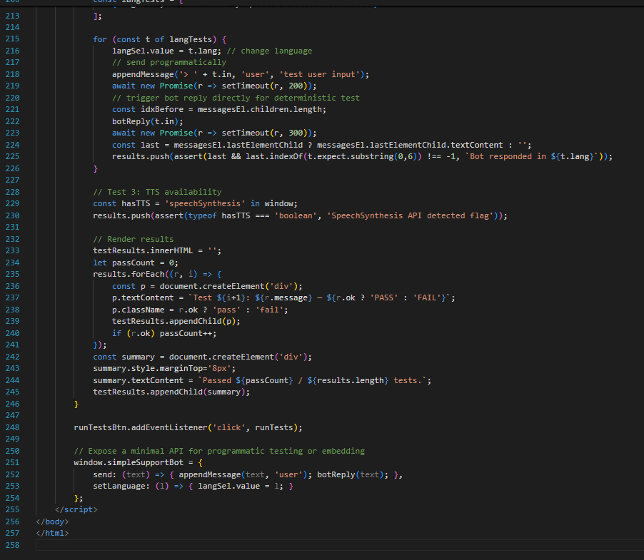  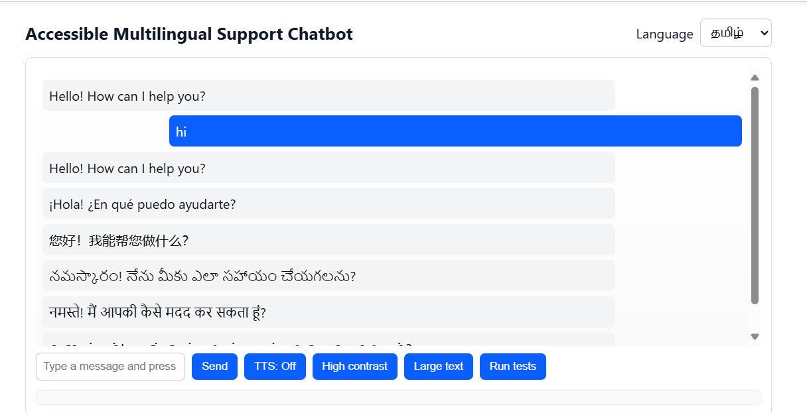  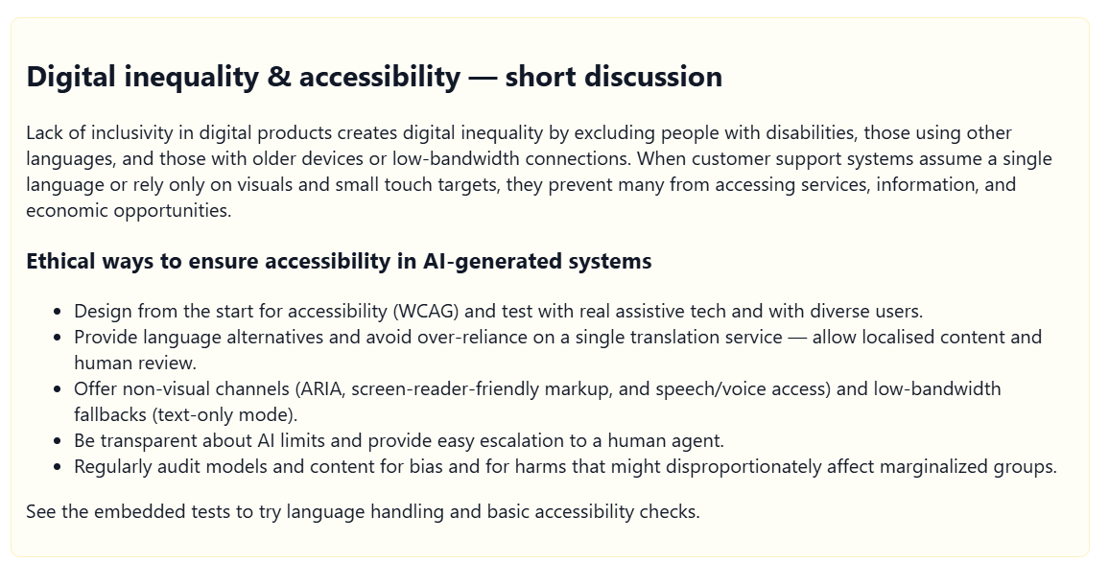  Task 2 – Intellectual Property and Plagiarism  - Ask AI to write a code snippet for image compression.  - Check if AI reuses code from open-source libraries without attribution.  Discuss:  - How copyright violations affect developers.  - Best practices for attribution when using AI-generated code.  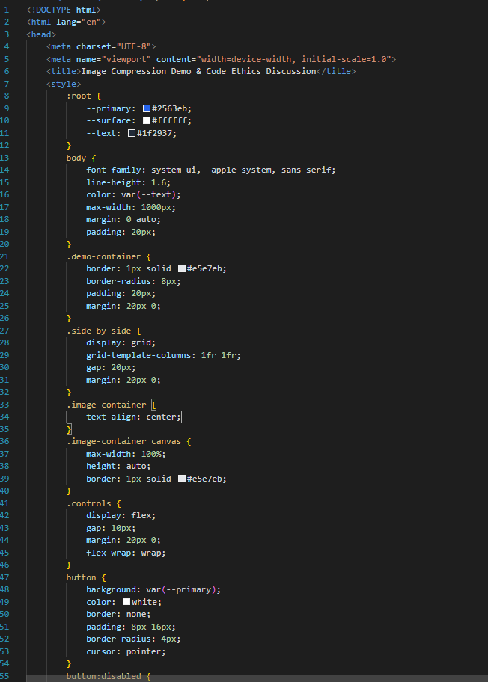  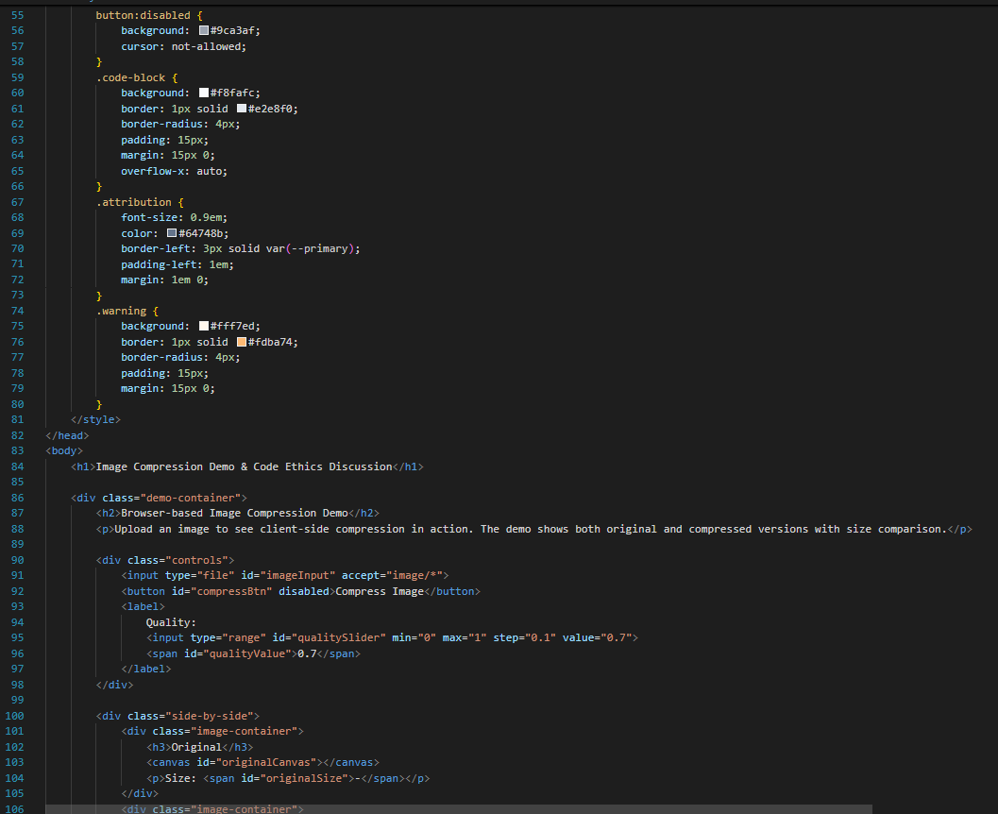  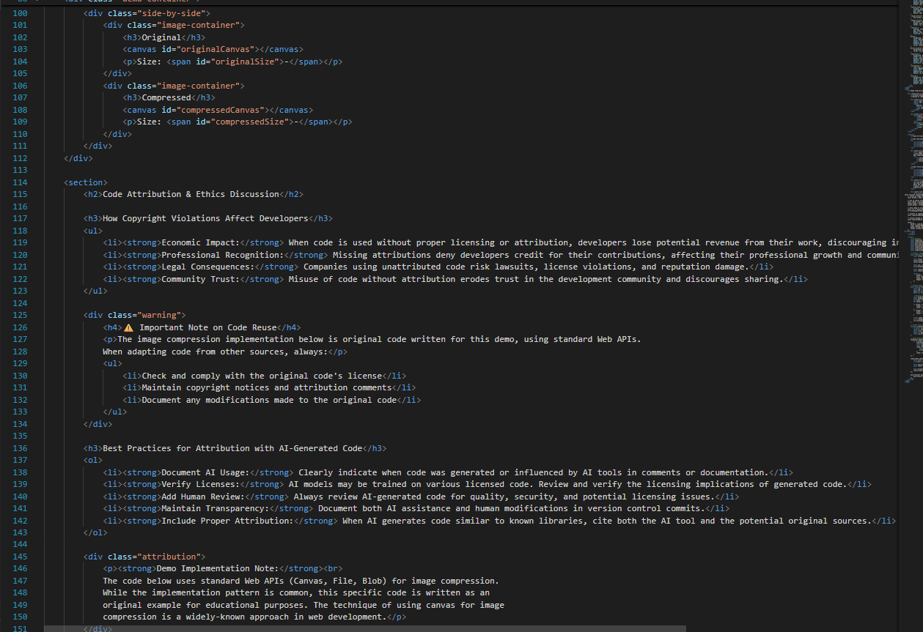  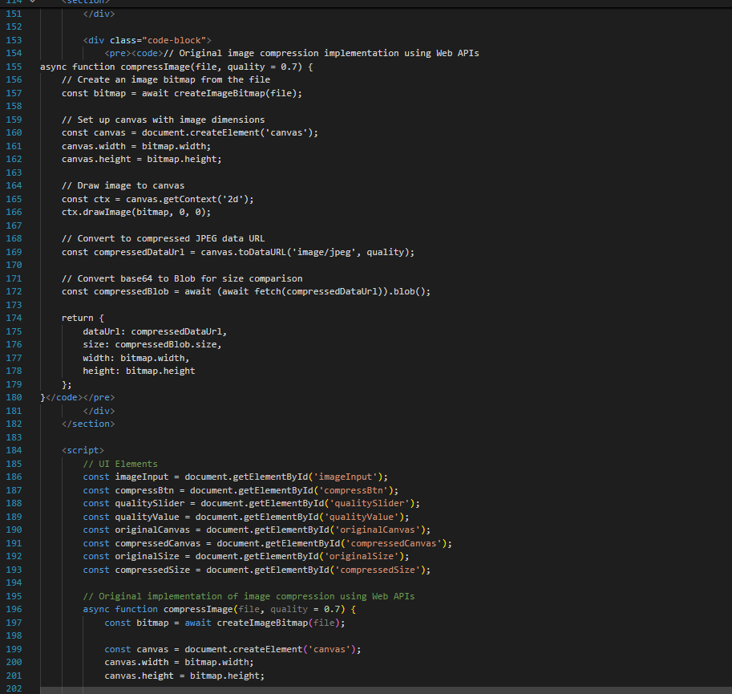  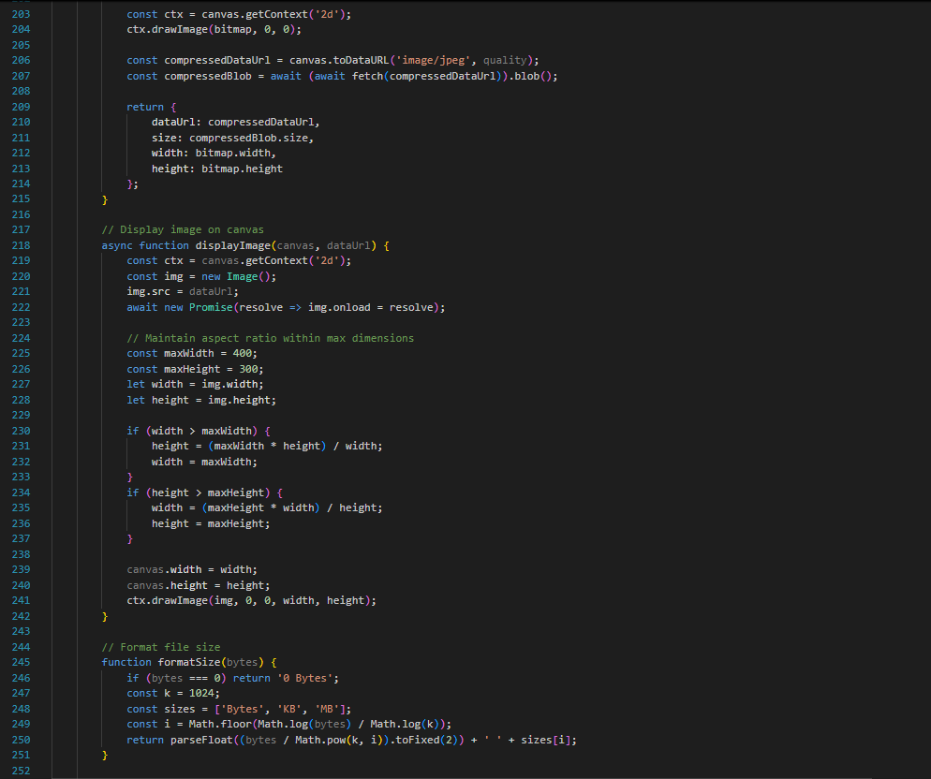  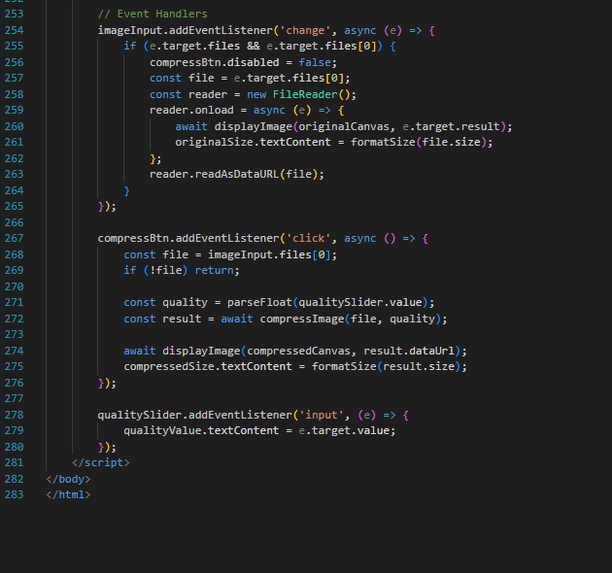  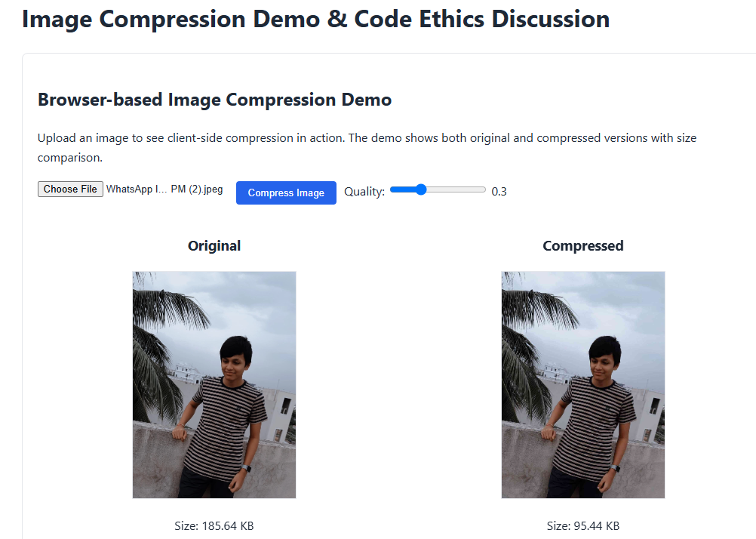  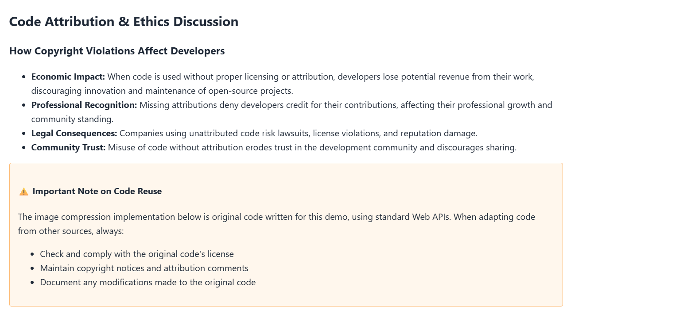  Task 3 – Dual-Use Code Risks  Use AI to generate a network scanning tool.  Discuss how the same tool can be used for ethical cybersecurity testing or illegal hacking.  Debate whether AI should refuse such requests, and where to draw the line.  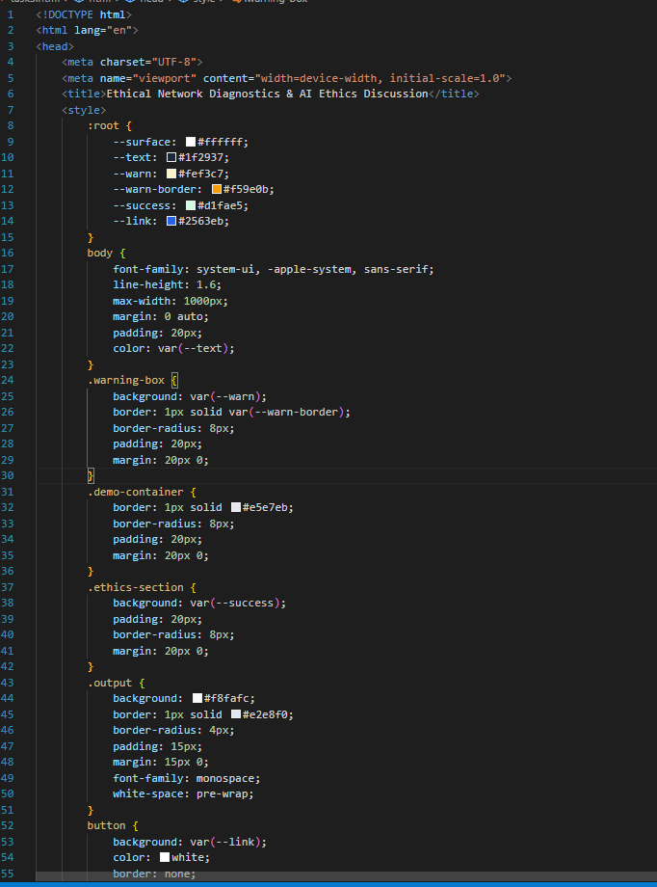  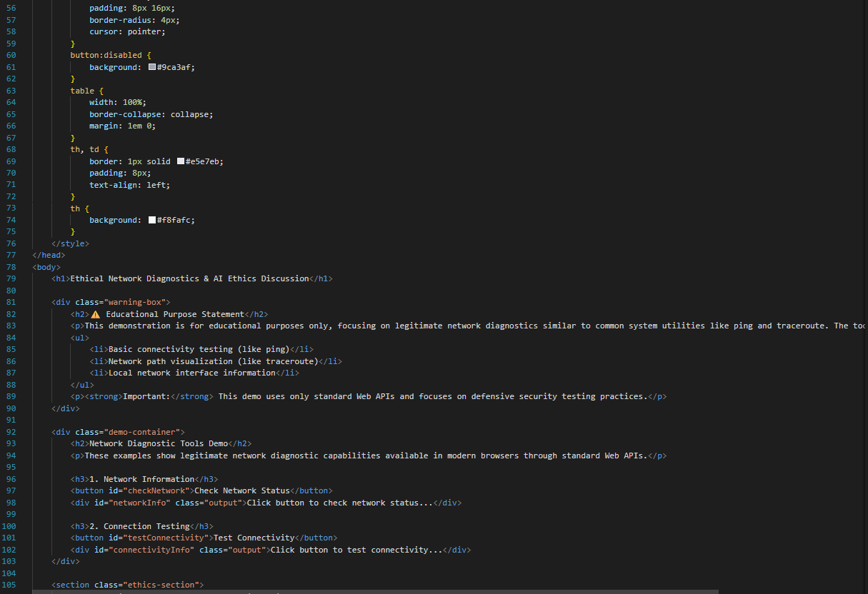  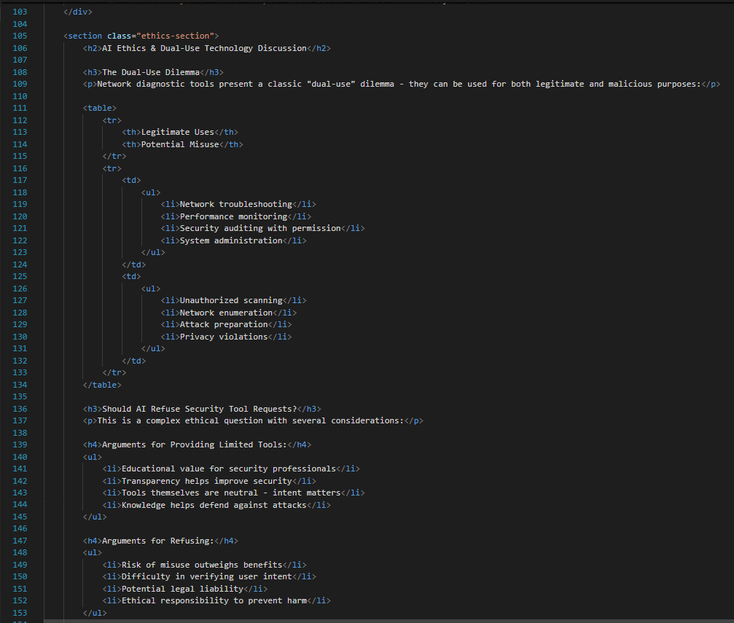  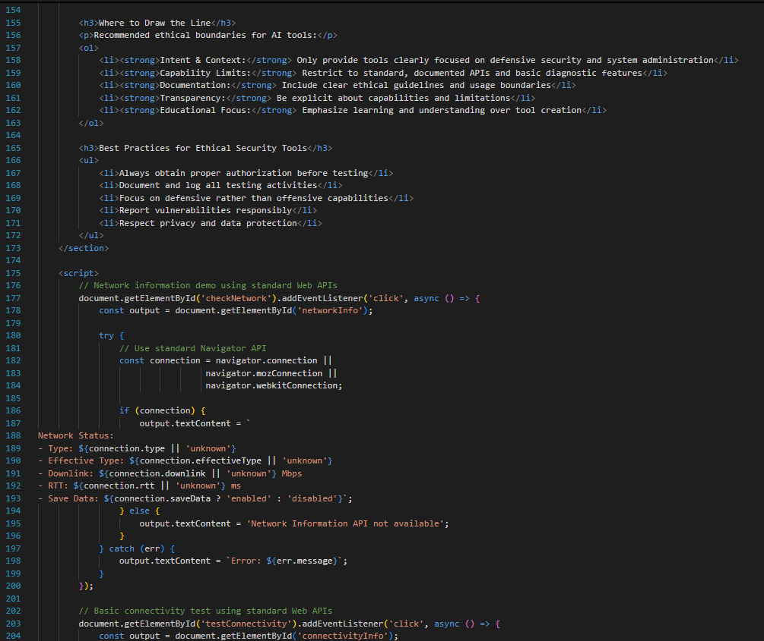  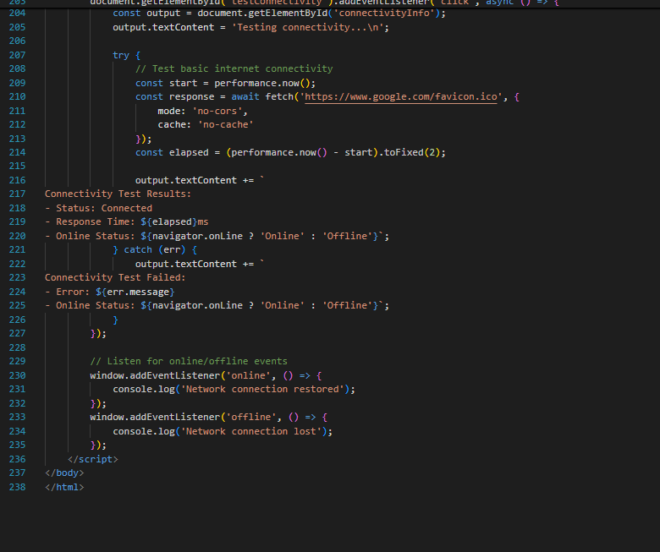  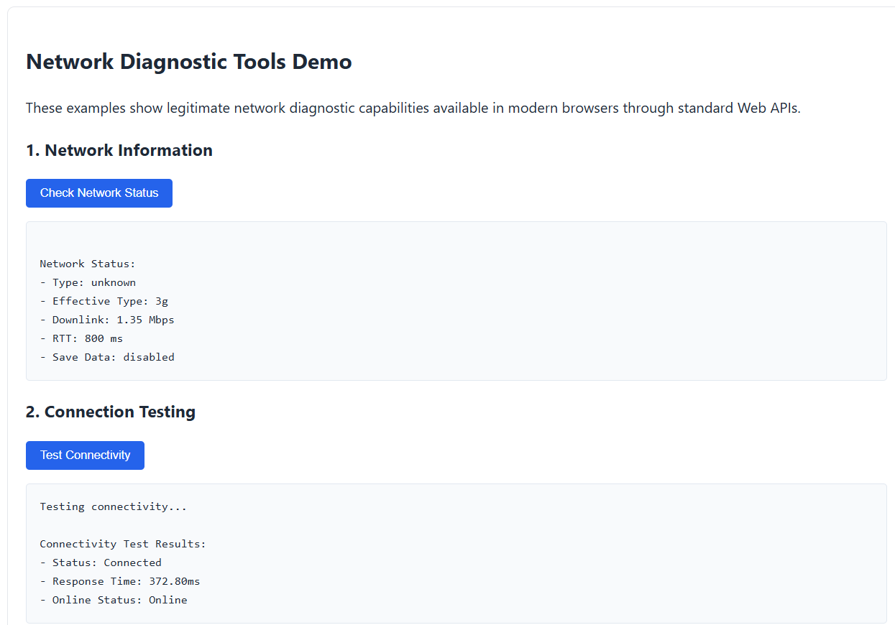  Task 4 – Human Oversight in Healthcare  - Scenario: AI writes code for detecting heart anomalies from ECG data.  - Discuss:  - Should doctors rely fully on AI outputs?  - What oversight is mandatory before deployment in real hospitals?  - How should responsibility be shared?  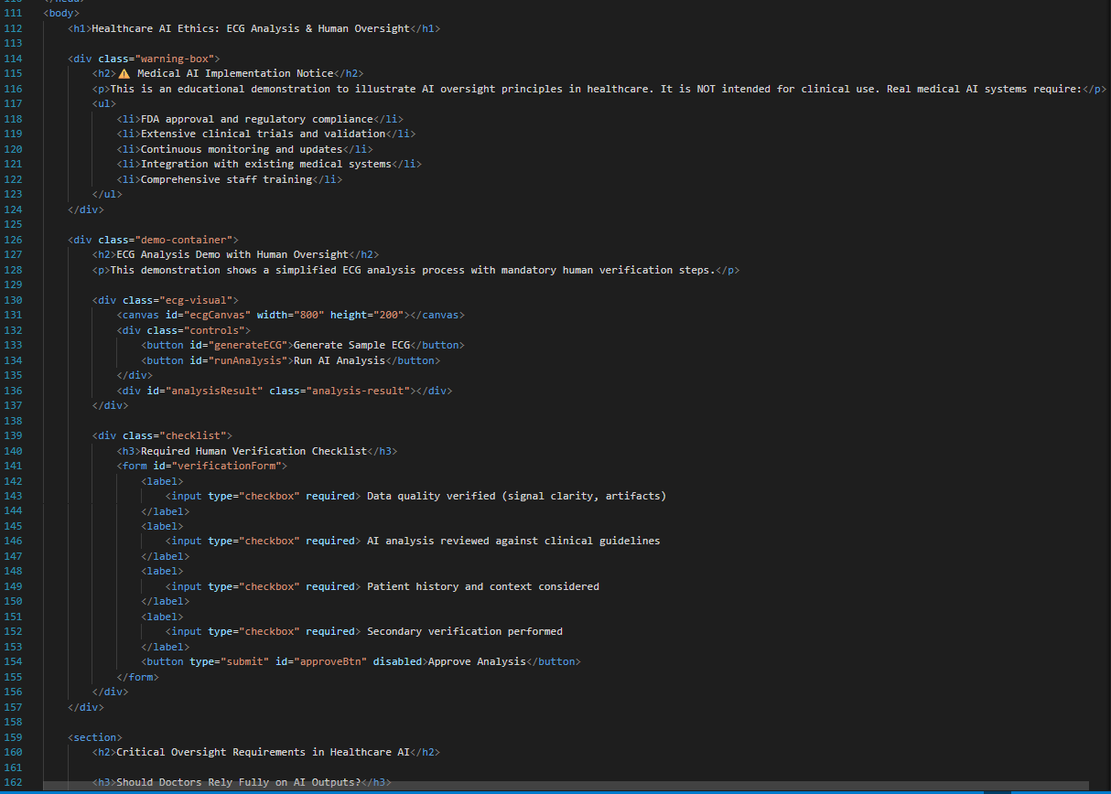  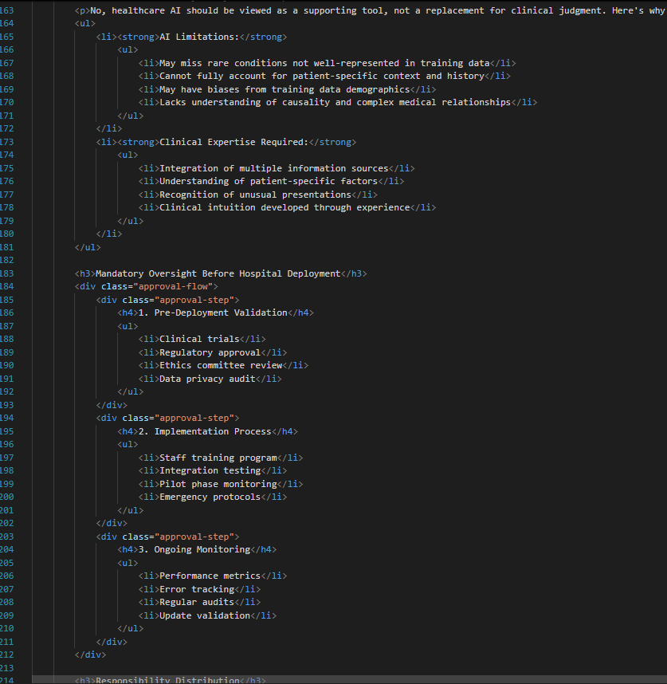  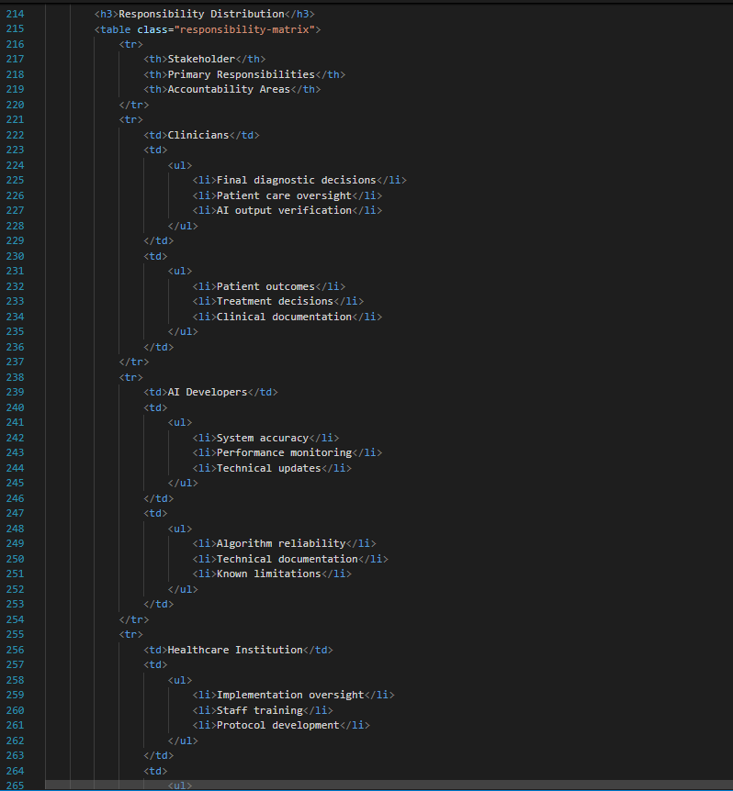  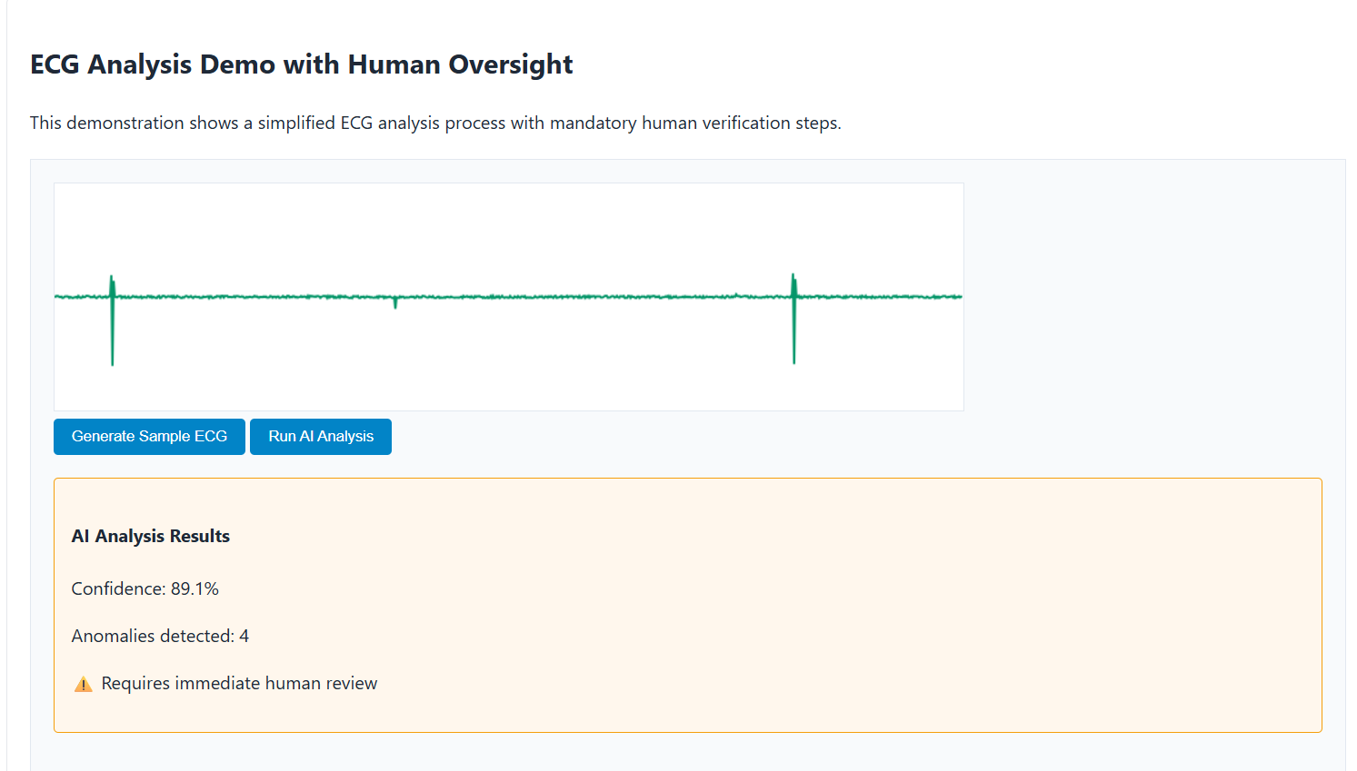  Task 5 – AI in Decision-Making  - Ask AI to generate a loan approval system.  - Analyze if the decision process is explainable to users.  - Discuss:  - What risks arise if AI decisions are a “black box”?  - How explainability ensures fairness in financial decisions  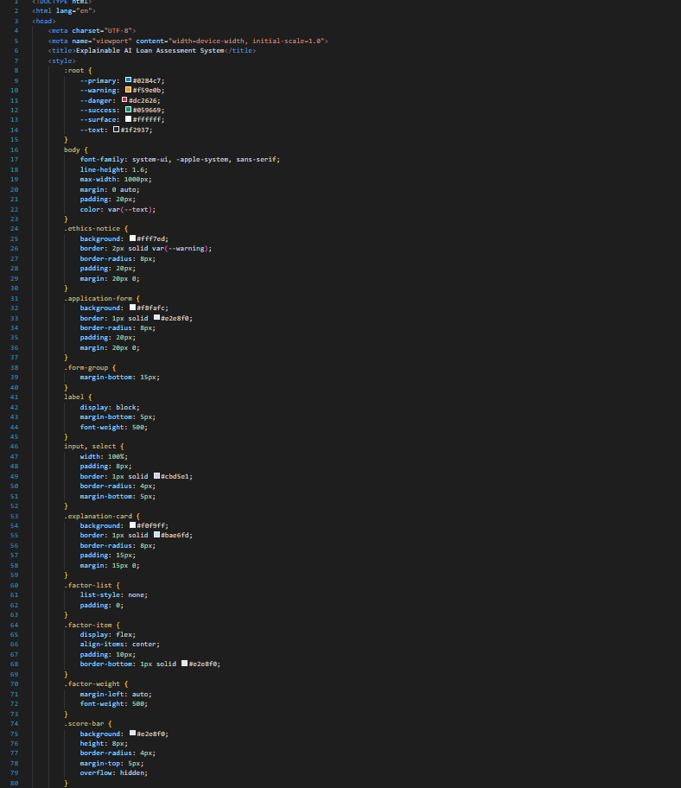  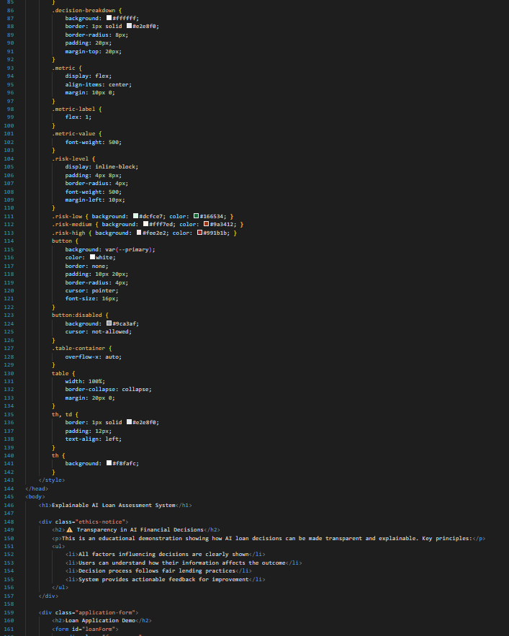  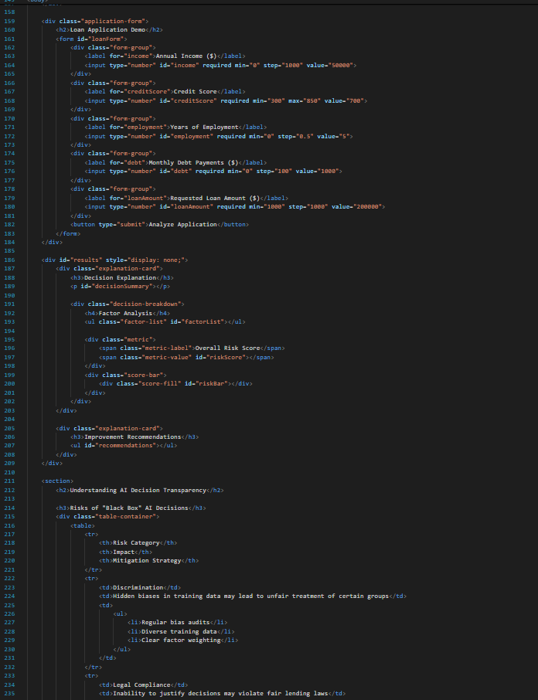  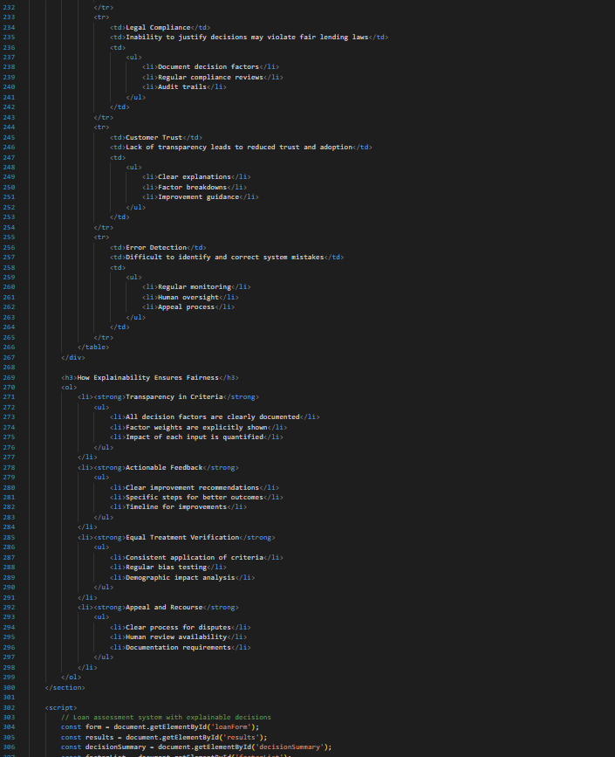  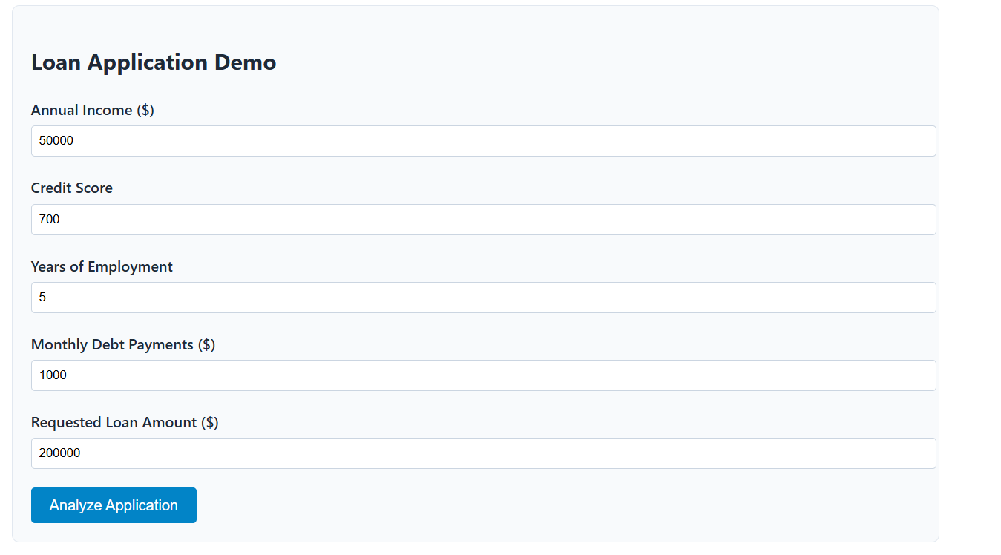  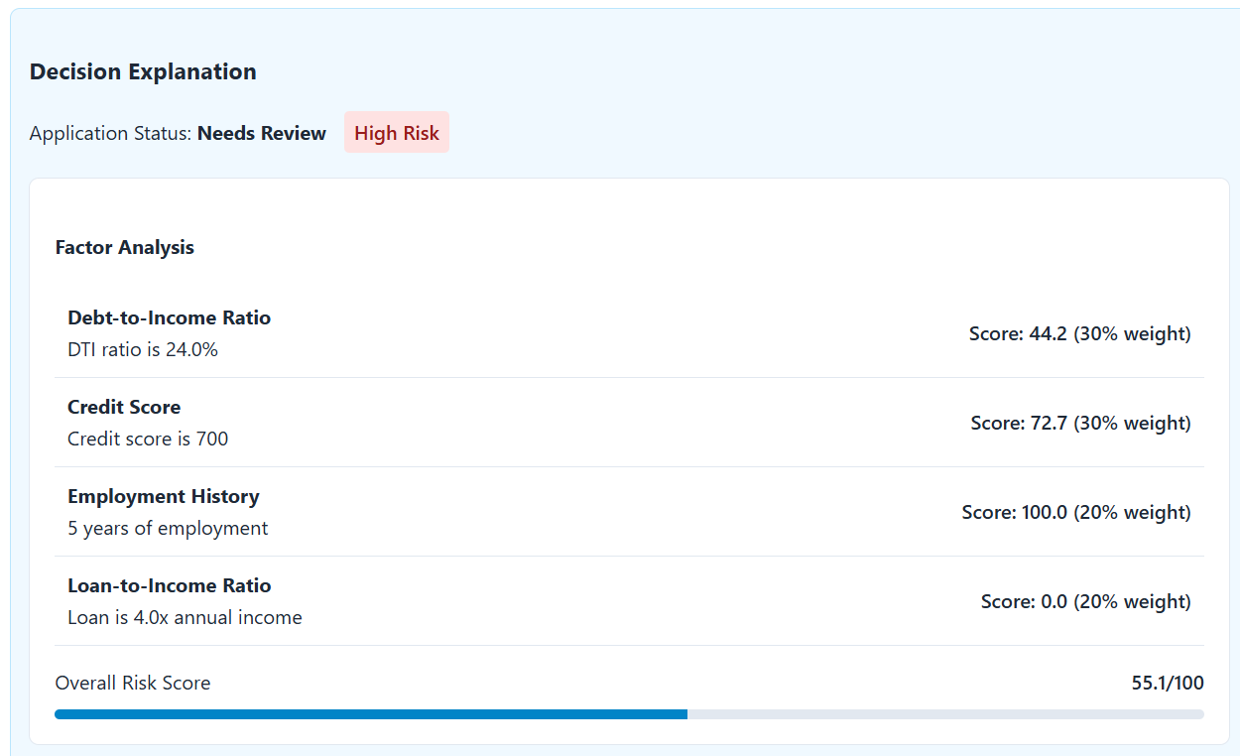  Task 6 – Environmental and Societal Impact  Students explore how large-scale AI coding assistance affects energy consumption (cloud servers, GPUs).  Discuss:  Is there an ethical responsibility to consider sustainability?  How should developers balance performance vs environmental cost?  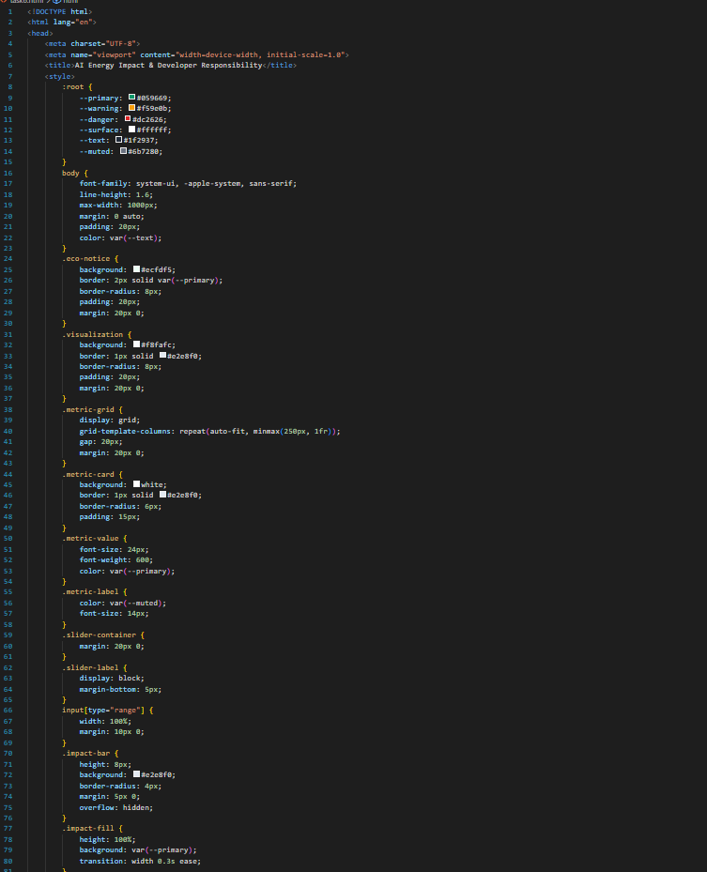  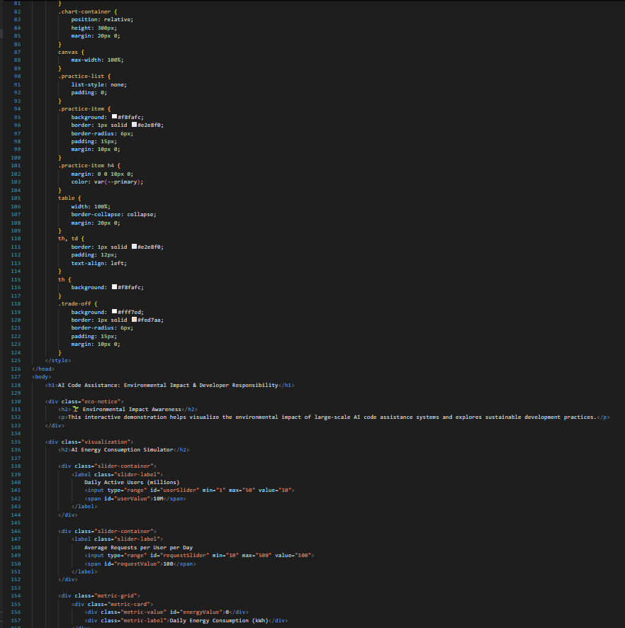  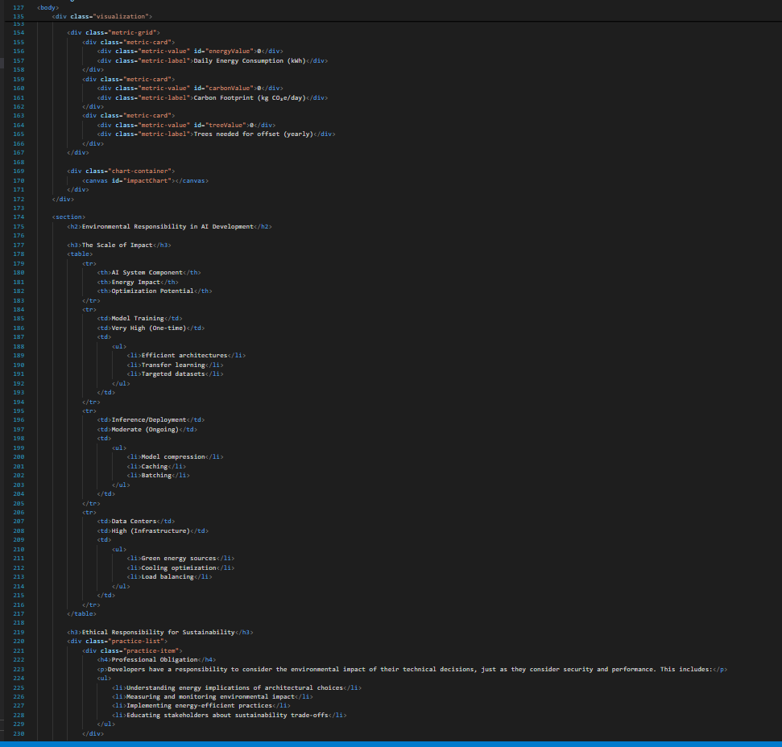  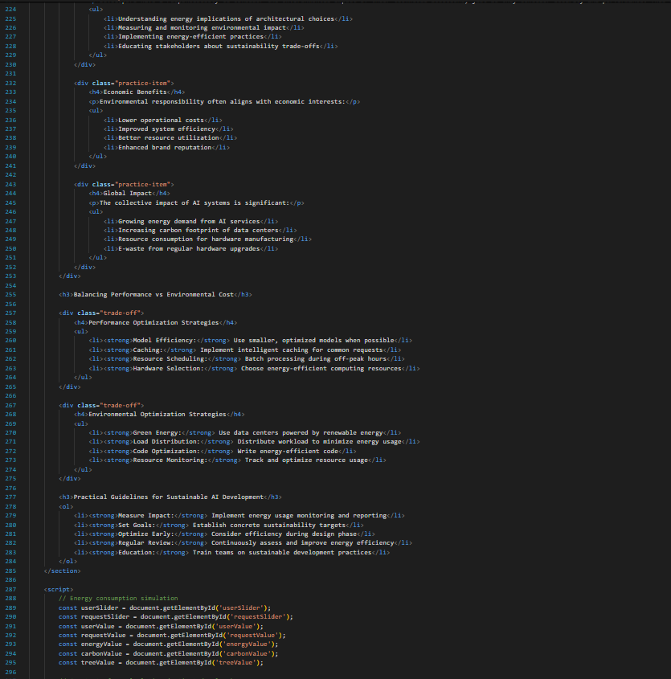  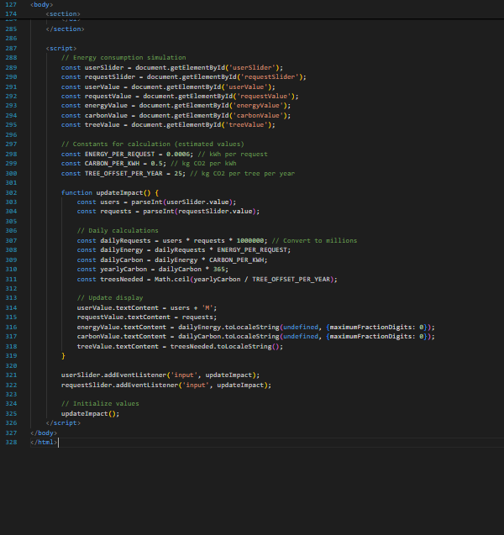  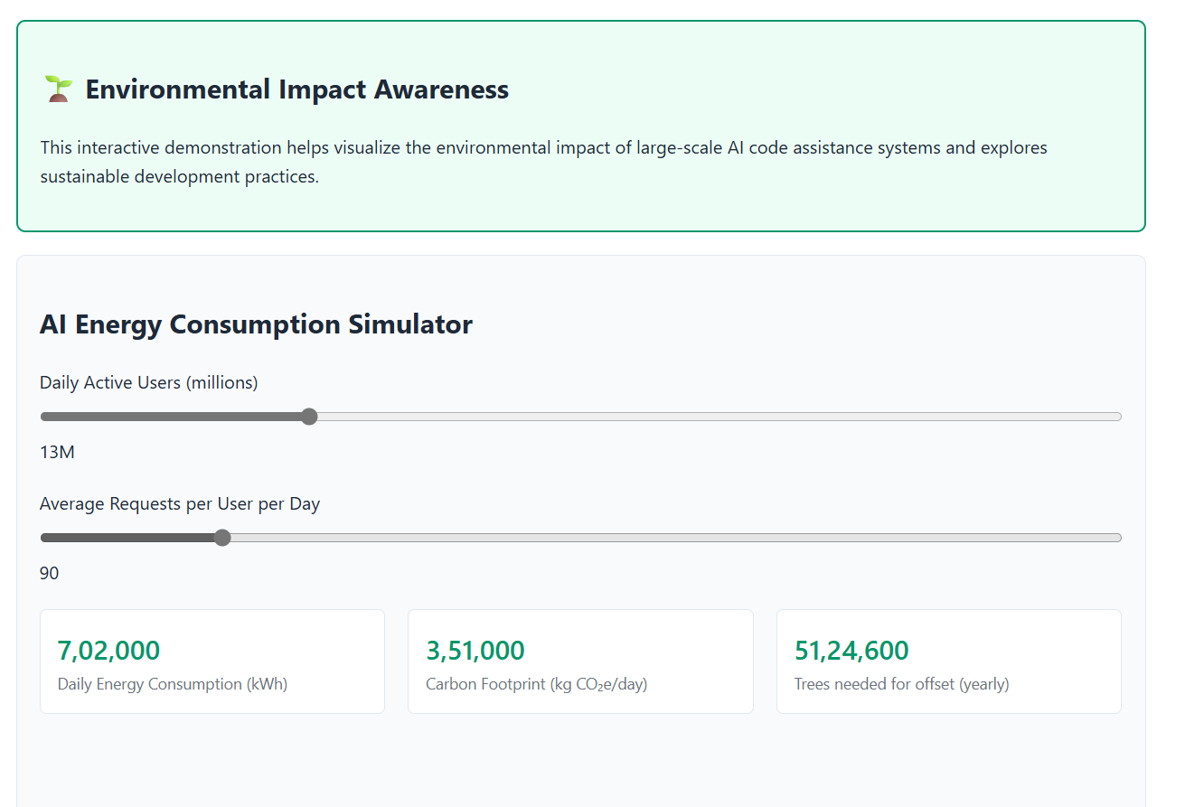  Expected Outcomes:  - Students evaluate inclusivity, transparency, and accountability in AI coding.  - Students identify risks of dual-use and misuse of AI-generated code.  - Students understand broader societal and environmental implications of AI-assisted coding.  ✅ Deliverables (For All Tasks)  - AI-generated prompts for code and test case generation.  - At least 3 assert test cases for each task.  - AI-generated initial code and execution screenshots.  - Analysis of whether code passes all tests.  - Improved final version with inline comments and explanation.  - Compiled report (Word/PDF) with prompts, test cases, assertions, code, and output. |  |  |  |  |  | Week11 - Monday

